**Notes to Build Market Data Physical Servers**

1) nslookup Host

2) Ping IP to Ensure doesn't already exist

3) Create Host in Satellite

Get Mac Address for eth4 & eth6 from iLo using ONEVIEW (<https://ldnpinfmon10/#/login> ) - EU

and using you “-a” login OR

Get Mac Addresses for eth6 & eth4 from Ilo of Server (<https://ihostname>) 🡪 system information🡪 Network🡪 eth4 = Port 1

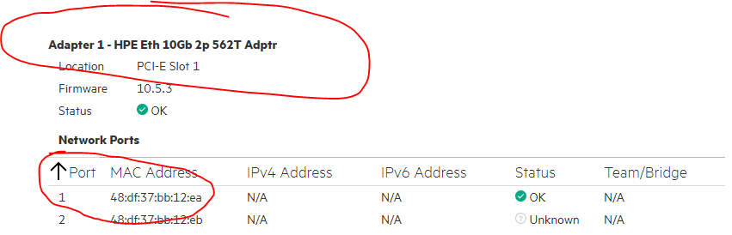

And Mac Address for eth6 ( Boot Device )

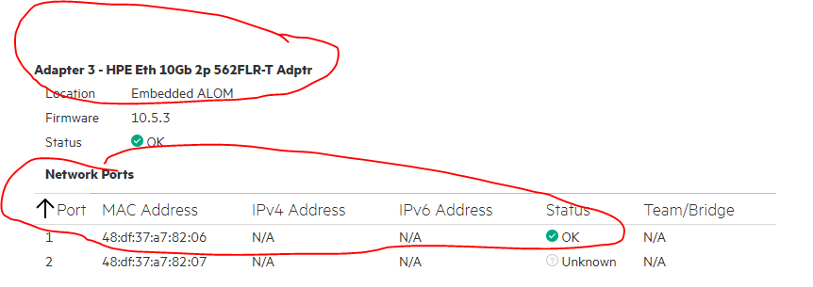

Add Subnet in Satellite if it does not exist .

1. In Satellite Create Host --> only setup eth6 Interface & eth4 in Satellite -->
2. initally only setup Redhat-hardening Ansible job

c) Download Full ISO

See screen shots below.

Creating Host in Satellite :

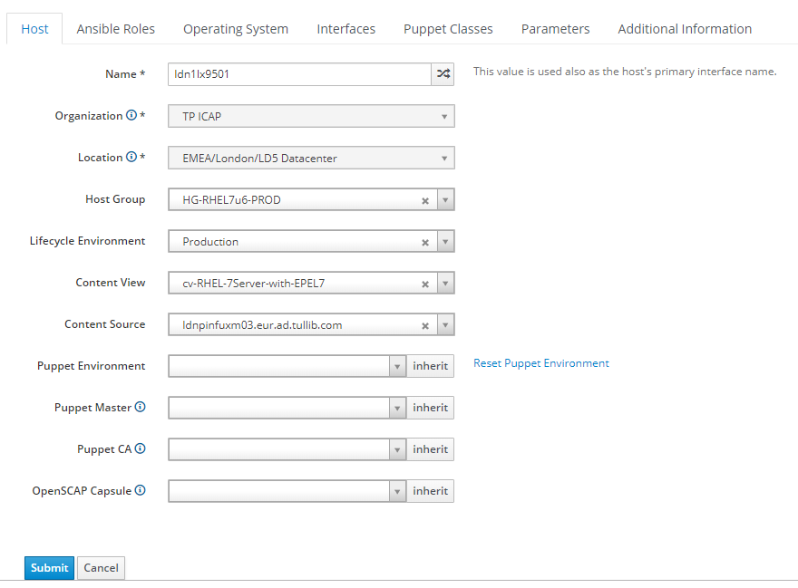

Setting up Ansible Jobs :

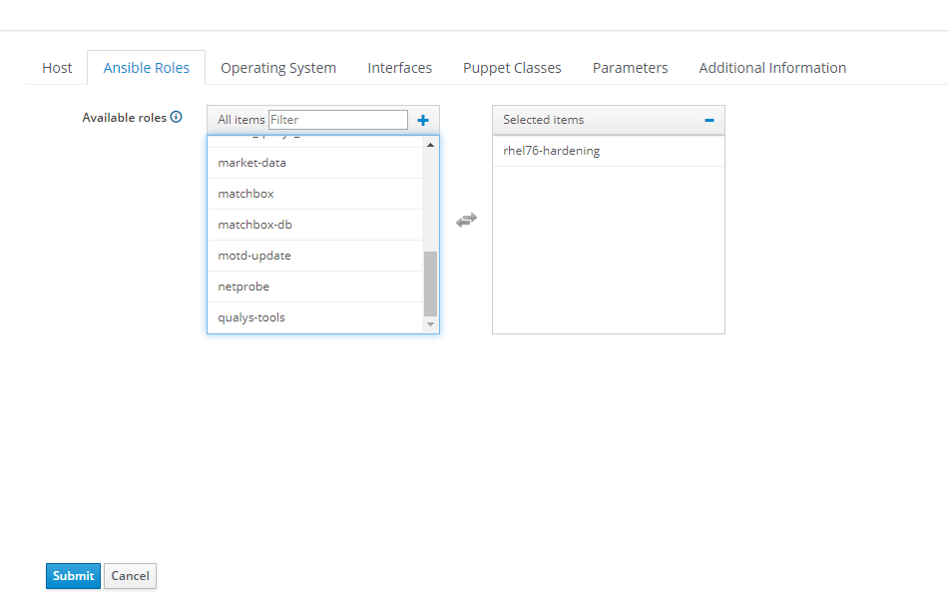

Take defaults & enter only the root password (s5tbu1ld)

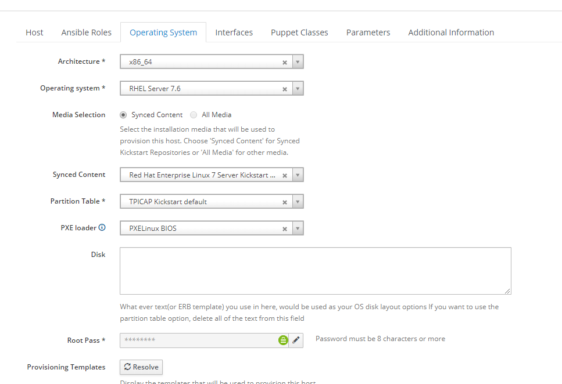

Now In Satellite Edit Interface eth6

Click Edit interface

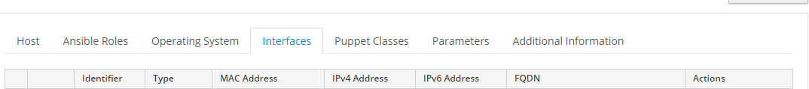

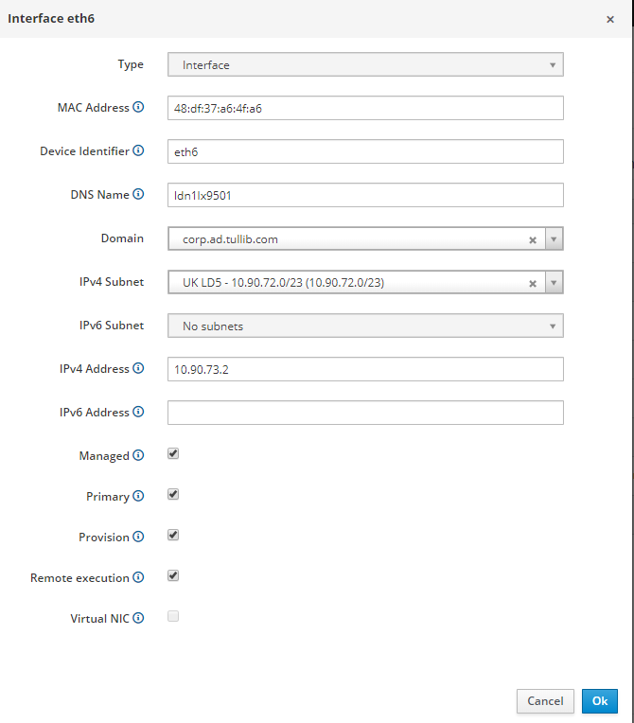

Submit & from next screen

Click Add Interface

Now Add eth4

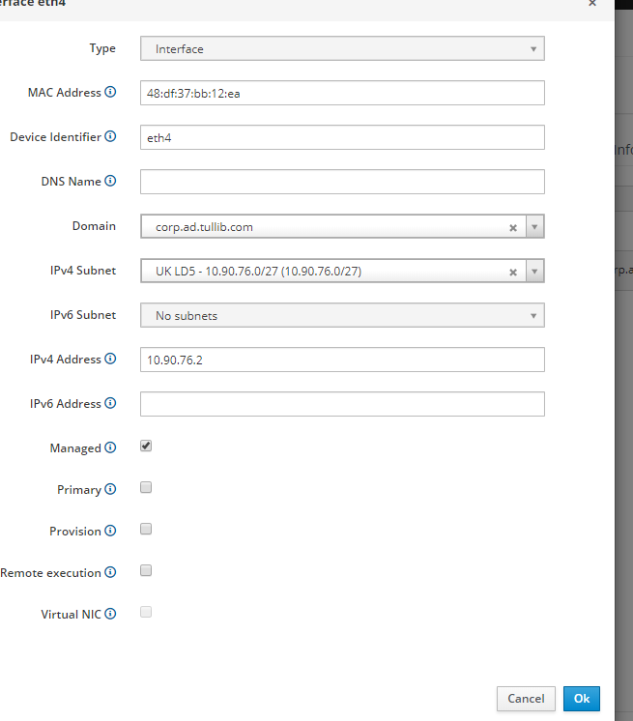

Submit and then you get screen below

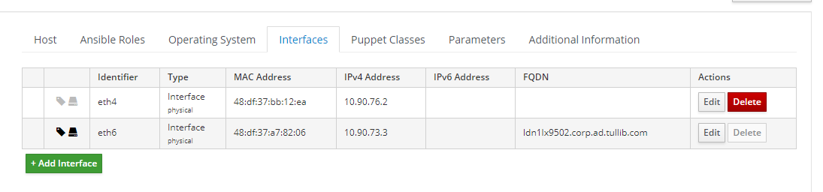

Leave Puppet Classes as it is

Leave Parameters as it is

Additional Information – Select HP DL360 Gen10

Check & Submit

Download ISO

Then Go To console of Server :

4) Boot Host from ISO --->

Goto iLo --> https://ihostname (e.g https://ildn1lx9500)

Enter Console --> Black Screen at Bottom

Attach CD/DVD that you downloaded

Click Power Momentary Press --> To reboot

F11 --- > Legacy --> One Time Boot ( option 1)

It should now boot off iso

5) At Post Installation Step --> Eject CD/DVD ( It should eject automatcically but doesn't seem to do it - think it needs a Eject after Reboot in Kickstart default Template)

6) Login on console & test Root login ( s5tbu1ld)

7) Re-run Ansible Job Only as it may have got que'ed and not run 🡪

Goto Monitor🡪 Jobs -🡪 select your job -🡪 Rerun option there

8) SSSH on to Server ;

login as root and check eth4 is configured and up

edit /etc/sysconfig/network-scripts/ifcfg-eth6 & ifcfg-eth4 to set PEERDNS=NO otherwise it

modifies /etc/resolv.conf incorrectly on reboot. Test with Reboot after modifying.

Reboot

9) Go To satellite Screen for the Host

Edit Host for Ansible Jobs remove previous job (rhel76-hardening) and include :

Appdynamics-Machine-Agent

cmdb-file-update

motd-update

create-qualys-user

common-tools-realm

See Screen Shot below 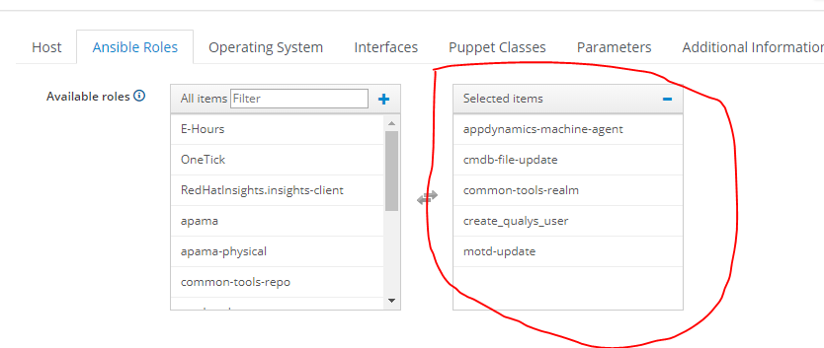

Submit ; Run Ansible Jobs

10) Go To satellite Screen for the Host

Edit Host for Ansible Jobs, remove previous jobs, and include :

market-data-phys

Submit and Run Ansible Jobs & Reboot ;

check both interfaces are configured ; & resolv.conf is like ldn2lx9608

11) Wait 10-15 for AD groups to be reflected in Realm ( sometimes its a lot quicker)

Test login as yourself with "-a" account

Run getent group -s sss corp-unixsa-linux

getent group -s sss corp-marketdata-linux

getent group -s sss dna_support

Check All Market Data File Systems are present under /opt/dna

12) Upgrade BIOS & Additional OS Settings

Edit Host in Satellite and remove old ansible job and add gen10mdsysreq ansible job

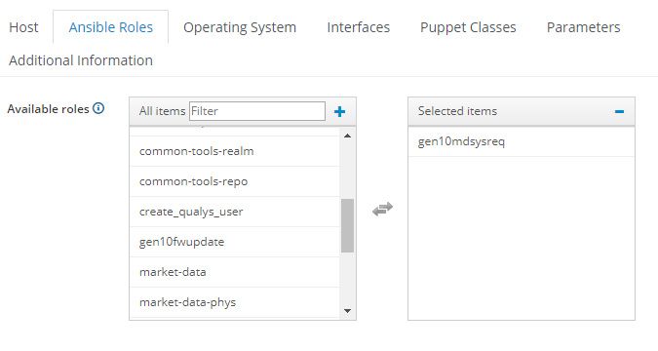

Submit and run Ansible Job for this host

View progress of Job in Satellite By clicking on host at bottom OR

In Satellite -🡪 Monitor 🡪 Jobs -🡪 your Job

After Job shows Complete in Satellite check OS settings /etc/rc.d.rc.log, /etc/sysctl.conf ..etc

poweroff -p

Momentary Press from Console (HTML5)

You can check BIOS settings from the attachment sent, should be OK as long as no errors in

ansible job.

13) Upgrade Firmware – This will take about 30mins just to run the ansible job

Edit Host in Satellite and remove old job and add gen10fwupdate ansible job

Submit and run Ansible Job for this host

View progress of Job in Satellite By clicking on host at bottom OR

In Satellite -🡪 Monitor 🡪 Jobs -🡪 your Job

After Job shows Complete in Satellite check logs

Check logs after firmware/drivers upgrade ( otherwise logs are removed after reboot)

/var/tmp/sum/localhost

sum_log.txt , sum_detail_log.txt, deploy.log

poweroff -p

Momentary Press from Console (HTML5)

Check Progress of reboot via Console as it takes a while

After reboot do sanity checks

**Server Build Complete.**